**Project : Capstone 1**

You have been hired as a Sr. DevOps Engineer in Abode Software. They want to implement DevOps Lifecycle in their company. You have been asked to implement this lifecycle as fast as possible. Abode Software is a product-based company and their product is available on this GitHub link. <https://github.com/hshar/website.git>

For performing below project first we have using Terraform for AWS instance Create

Step 1 Login to root account and create a new user

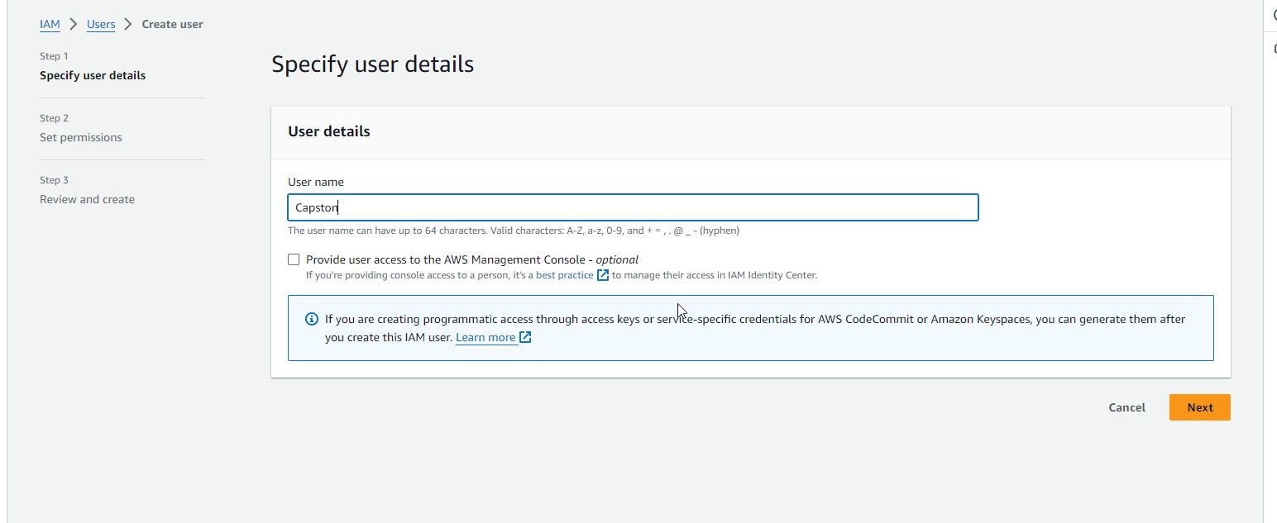

Create access key of the user

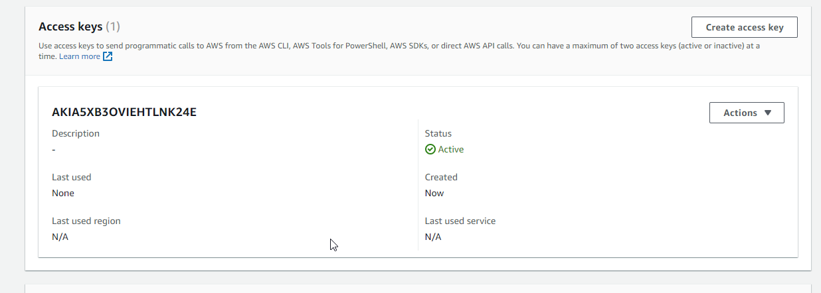

Here im launching 3 ec2 using terraform configuration

provider "aws"{

  region  = "us-east-1"

 }

resource "aws_instance" "master" {

  ami                    = "ami-080e1f13689e07408"

  instance_type          = "t2.micro"

  key_name               = "capston_key"

  tags = {

    Name = "Master"

  }

}

resource "aws_instance" "Slave-1" {

  ami                    = "ami-080e1f13689e07408"

  instance_type          = "t2.micro"

  key_name               = "capston_key"

  tags = {

    Name = "Slave-1"

  }

}

resource "aws_instance" "Slave-2" {

  ami                    = "ami-080e1f13689e07408"

  instance_type          = "t2.micro"

  key_name               = "capston_key"

  tags = {

    Name = "Slave-2"

  }

}

First initialize the terraform and validate the configuration.

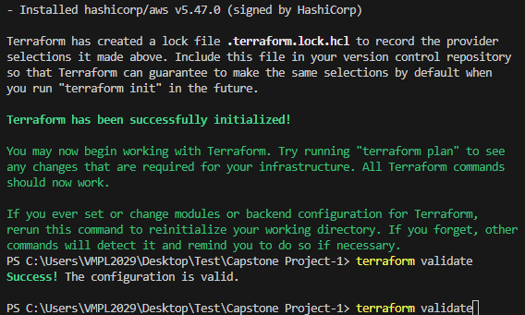

And then terraform apply

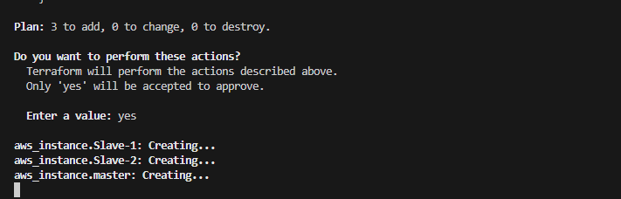

Finally it has successfully created the resources

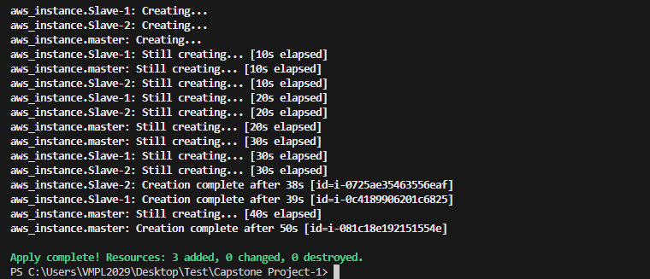

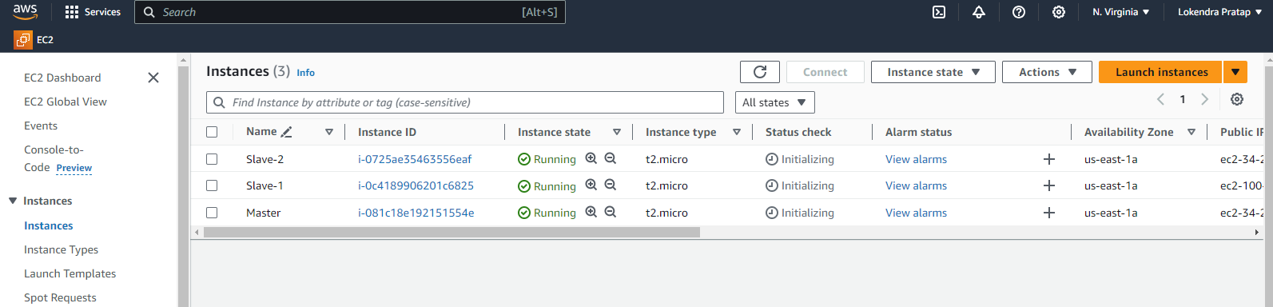

Following are the specifications of the lifecycle:

1. Install the necessary software on the machines using a configuration management tool

Here we need to install Ansible on master node and

For performing below project need below software

1. Java, Jenkins ,Docker(on master node)
2. Java docker ( slave Node)

So now here we have installing all the software using ansible.

Now here we need to install ansible on master node manually

## Refer to [Installing Ansible on Ubuntu](https://docs.ansible.com/ansible/latest/installation_guide/installation_distros.html#id6)[ℑ](https://docs.ansible.com/ansible/latest/installation_guide/installation_distros.html#installing-ansible-on-ubuntu)

Ubuntu builds are available [in a PPA here](https://launchpad.net/~ansible/+archive/ubuntu/ansible).

To configure the PPA on your system and install Ansible run these commands:

sudo apt update

sudo apt install software-properties-common

sudo add-apt-repository --yes --update ppa:ansible/ansible

sudo apt install ansible

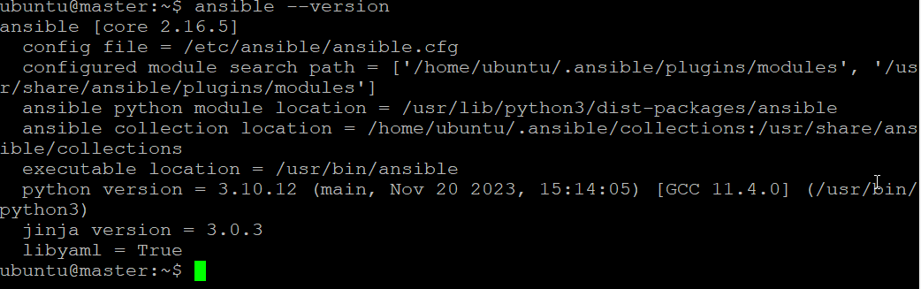

Now we need to configure all node to master node in ansible inventory file

Copy ssh key in slave 1 and slave 2

Finally check slave host connected with master node

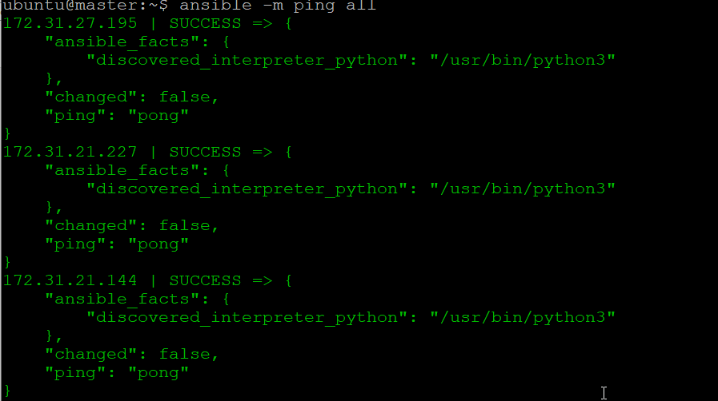

Installing Jenkins using ansible playbook on master node

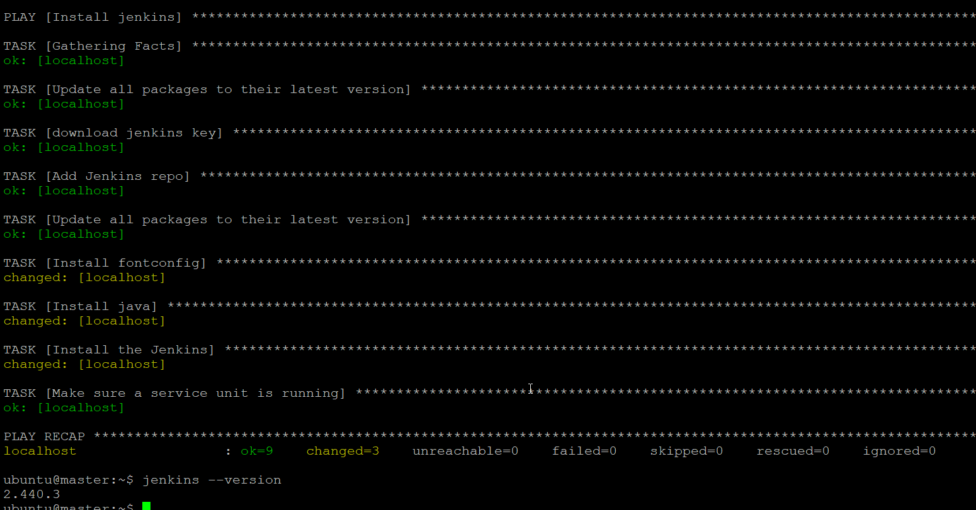

Install java and docker using ansible playbook on slave node

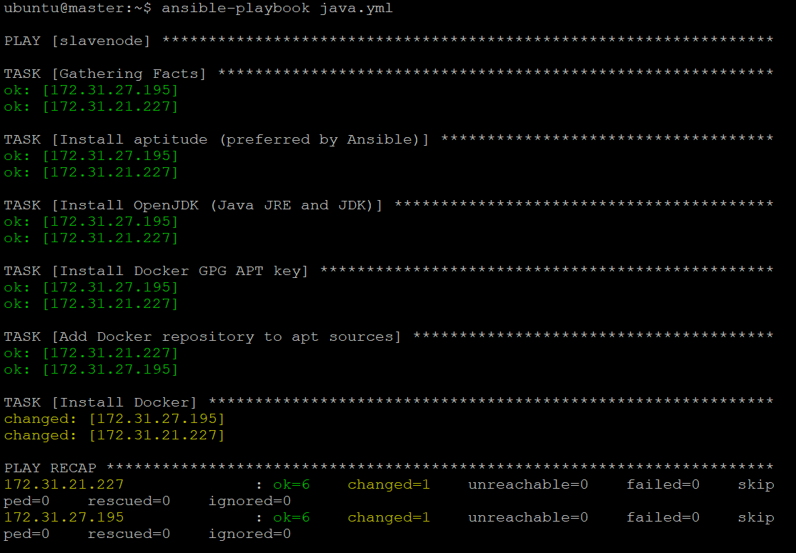

Now project asked

2. Git workflow has to be implemented

For performing this, we need to configure webhook in git-hub repo

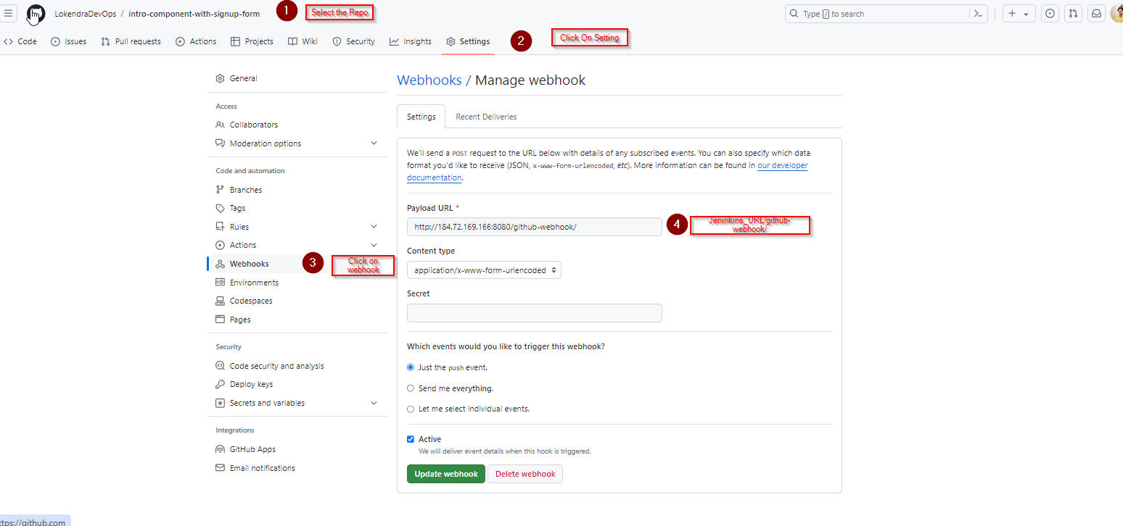

Now project asked

3. Code-Build should automatically be triggered once a commit is made to master branch or develop branch.

a. If a commit is made to master branch, test and push to prod

b. If a commit is made to develop branch, just test the product, do not push to prod

Solution

To perform above task we need to create a jenkin job

Here im using job type pipeline

